|  |  |  |  |  |  |  |  |  |
| --- | --- | --- | --- | --- | --- | --- | --- | --- |
|  |  | | | **Version No.:** | | | 1 | |
| **Date :** | | | **26th February 2020** | |
| **Project Name:** | Connected Living Spaces | | | | | | |
| **Project Code:** | PW20CBR01M | | | | | | |
| **Status:** | **Current** | | | | | | |
| **Document Type:** | **Controlled** / **Uncontrolled** | | | | | | |
| **Connected Living Spaces** | | | | | | | |
| **Smart Automation for educational institutions- Access Control Systems, Facial Recognition, Mood Detection and Rejuvenation,Automation of appliances,Automatic Cooling and Heating Systems,Temperature monitoring and Leakage detection.** | | | | | | | |
| **Prepared By:** | | | | **Reviewed By:** | | | |
| **Name** | | **Date** | | **Name** | | | **Date** |
| Chirag N Vijay | | 26/02/20 | |  | | |  |
|  | | |  |
| DG Sudheer | | 26/02/20 | | **Approved By:** | | | |
| **Name** | | | **Date** |
| Dhanush Ravi | | 26/02/20 | |  | | |  |
|  | | |  |
| **Distribution List** | | | | | | | |
| **Project Representative(s)** | | | | | **Guide Representative(s)** | | |
| 1. Chirag N Vijay 2. DG Sudheer 3. Dhanush Ravi | | | | | 1. Prasad Honavalli 2. Charanraj B R | | |

TABLE OF CONTENTS

Definitions, Acronyms and Abbreviations 3

References 3

Change History 3

1.0 Introduction 4

1.1 Overview 4

1.2 Scope 4

2.0 Design Constraints,Assumptions and Dependencies 4

3.0 Design Description 4

3.1 Usecase Diagram 5

3.2 Class Diagram 6

4.0 User Interface Diagrams 7

5.0 Reusability Considerations 7

6.0 Traceability Matrix 8

Definitions, Acronyms and Abbreviations

* IOT-Internet of Things
* MQTT- Message Queueing Telemetry Transport
* DHT-Digital Humidity and Temperature

References

* Sensor based home automation and security system - M. H. Assaf, R. Mootoo, S. R. Das, E. M. Petriu, V. Groza and S. Biswas, 2012 IEEE
* Microcontroller based Home Security System with Remote Monitoring - Nikhil Agarwal, 2012 ICEDSP
* Room Temperature Control and Fire Alarm/Suppression IoT Service Using MQTT - Do-Hun Kang, Min-Sung Park, 2017 PlatCon
* Messaging Queue Telemetry Transport IOT based Messaging Protocol - Suvam Mohanty & Sagar Sharma , Vaibhav Vishal, 2016 IRJET
* IoT real time data acquisition using MQTT protocol - R A Atmoko & R Riantini , Vaibhav Vishal, 2016 ICoPLA

**Change History**

This section describes the details of changes that have resulted in the current High-Level Design document.

|  |  |  |  |  |
| --- | --- | --- | --- | --- |
| **#** | **Date** | **Document Version No.** | **Change Description** | **Reason for Change** |
|  |  |  |  |  |
|  |  |  |  |  |
|  |  |  |  |  |

# Introduction

### 1.1 Overview

This document relates to the background and surrounding information regarding our project - Emotion detection using voice data. It deals with the scope, shortcomings, risks, architecture, etc. of the project and is meant to serve as documentation to the end-user who wishes to understand the project in detail and modify it to achieve better results.

## 1.2 Scope

With the digitalization of almost and everything the previous decade saw the rise of automating houses and offices with the advent of IOT and Industrial IOT.

Being a fairly new industry there is a scope for widespread innovation from scratch.

The modules can be used independently also as separate products.

Development of facial recognition systems, automatic heating, cooling, access control and leakage detection systems.

# 2.0 Design Constraints, Assumptions and Dependencies

The assumptions made is -The system never experiences WiFi and power failure.

Dependencies – Constant Uninterrupted WiFi,No power failures

Risks-

The following are the risks which can seriously affect the working of the product.

* Hardware Failures
* Pests biting wires
* Power Failures

# Design Description

This section clearly defines the interfaces that exist between two or more modules/classes.

This could be represented diagrammatically for better understanding of the system.

This section explains briefly about the major modules and classes.

* 1. ***Master Class Diagram***

### 3.1 Use Case Diagram

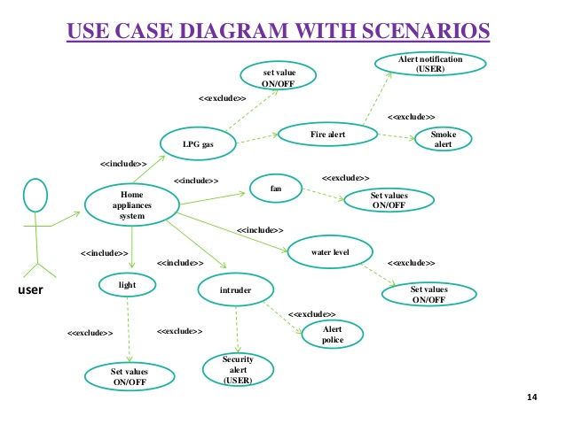

|  |  |
| --- | --- |
| **Use Case Item** | **Description** |
|  |  |
|  |  |

### Class Diagram

Here, a description of each class in this class diagram will be given. A diagram of the entire system will be given at a high level and then broken down into sub levels. Classes maybe repeated across class diagrams, to show the interfaces with other classes. The detailed explanation of each class with its methods will be covered in the low-level design document.

For Example

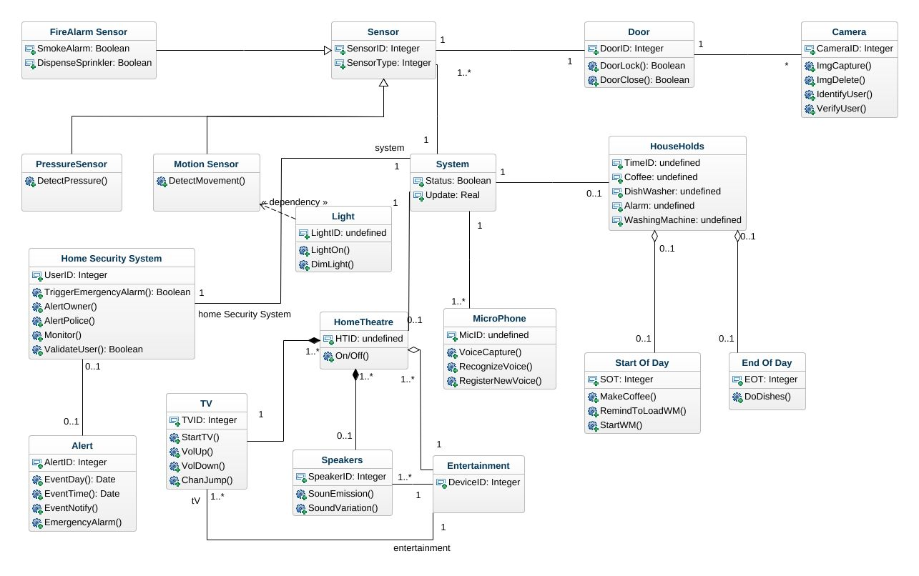

#### 

# User Interface Diagrams

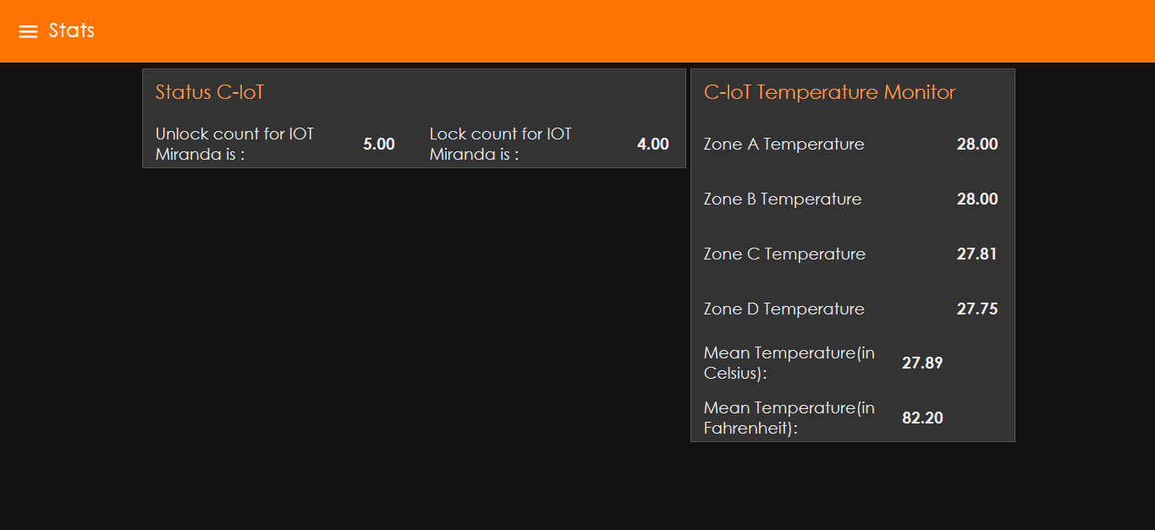

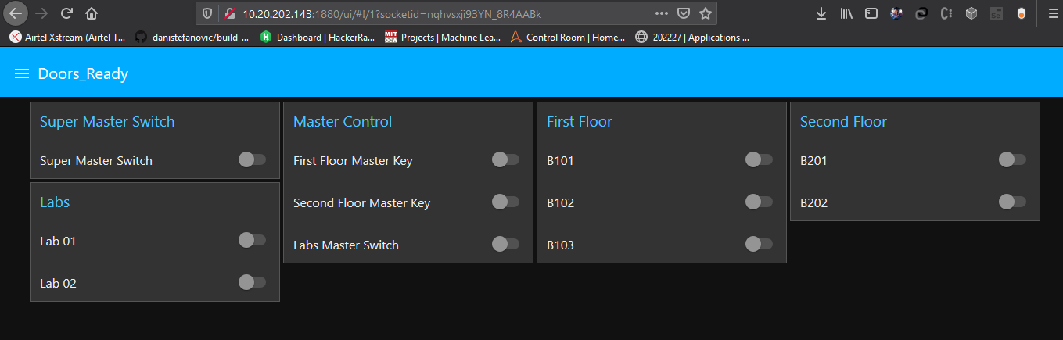

# Reusability Considerations

This section shall describe the reusability considerations planned for the project. They may comprise of the following:

* Project Components that are and can be generated with available reusable components
* Components that can be built in the project for reuse in the project

# Traceability Matrix

|  |  |
| --- | --- |
| **CRS Reference Section No.**  **and Name.** | **DESIGN / HLD Reference Section No.**  **and Name.** |
|  |  |
|  |  |
|  |  |